Does A Parent On Deployment Cause More Anxiety for Single Children Than It Does for Children with Siblings?

Student’s Name
Department, University
Course Number and Name
Instructor’s Name
Date

Contents
1. Introduction 3
1.1. Problem statement 3
1.2. Significance of this study 4
1.3. Hypothesis statement 4
2. Literature review 4
3. Theoretical framework 5
4. Conclusion 6
5. The research gap 6
6. Recommendations 7
7. References 7

Does A Parent On Deployment Cause More Anxiety for Single Children Than It Does for Children with Siblings?

Introduction
Children always love parental love at any moment of their growth (Cousins, 2017). However, this parental care is not always there due to occupational obligations. Such includes when either of the parents is deployed on military bases. The children feel the void, and this is revealed in many aspects of their lives. Their psychological stability is affected by long-term effects. Such includes evidence of sleeping disorders, increased anxiety and stress levels, low performance in school, increased maladaptive traits, as well an escalation in the rates of child maltreatment (Chartrand et al., 2008). Therefore, unless the parent watches the children's caregiving while they commit to job obligations, adverse effects of the action may strongly appear in children. The treating costs of such disorders are more costly than if such is mitigated. In addition, according to the World Health Organization, 70% of all the medical conditions that are evident individuals hard more than 80% of chances of being prevented (Shomali & Gotlib, 2019). Such illnesses are termed as "personal willed" occurrences. However, they happen by default and without one realizing the process of them happening.
The basis for this research proposal is connected to the family life of military parents and the effects it has on their children. According to research done on the conditions of the family connected to the military obligations, poor mental health among the family members, higher risks of divorce, and increased rate of suicides are evident. Further, the bond between the parents and the children is far much below the expected levels (Clark et al., 2018). This is due to the long seclusion moments that happen when the parents are in the line of duty. At such moments, the children miss parental love, and they can only have negative feelings in their inner self with the increased level of loneliness (Clark et al., 2018).
A child's mind is so tender and prone to change depending on the external factors present drastically. The environment in which they are raised affects their future rational decisions (Cramm et al., 2019). However, the structure of a family determines the extent of influence from an environmental factor in the child's upbringing. Families with more than one child are better placed to experience fewer psychological effects on their children than when a child is only one, in case the parents separated with the children for job obligation grounds (Camm et al., 2019). This research aims to discover whether the parents’ deployment causes more anxiety on a single child than when the child has siblings.

1.1. Problem Statement
Over the recent years, the psychiatric effects on the children connected to the families where either of the parents is military personnel has increased by 27% (Cunitz et al., 2019). This is a significant concern to the authorities as such children reveal a poor intercultural and developmental relationship with their counterparts. The worst cases are when there is only one child in the family. This raises many ethical and unethical dilemmas for the family and other international bodies. Does it mean one child-founded military family is weaker in mitigating a child's mental stamina? Alternatively, does it mean the issue can only be solved by having more children in the family? These issues form the basis of this research proposal.

Significance of This Study
The security concern of a nation will always be a critical element to be thought about at any point in time (Son, 2016). This will translate to military individuals being recruited day in day out. Many of these military individuals will always develop a desire to have a family, as age and social status demand. The decision of how many children such families are to have is entirely upon them to decide. Some will opt to have a single child, while others will not free until they raise few more children. Due to the type of occupation, such parents will always be committed many of the time, leading them to move away from their children. Since psychology wellness is a significant element in every child, the children affiliated with military families are also considered (Son, 2016). This proves the significance of this study in discovering the amount of anxiety caused while the parents are away. The idea of whether the evidence of such fear is more in single-child-based families or the multiple-based is the role of this research work. This thesis will assist in bringing the best remedies to solve whichever is the worst-case scenario.

Hypothesis Statement
To set up a specific outcome of this study, the question under research is the following:
Does a parent on deployment cause more anxiety for single children than it does for children with siblings?

Literature Review
In the last ten years, military deployment in the United States has significantly increased. The families and children associated with the military occupation have been psychiatrically affected by the deployments (Lester et al., 2013). The children have encountered absences from either of the parents or both. From the Psychological health of the military children department, more than two million children have been directly associated with mental conditions from the deployment actions of their parents (Lester et al., 2013). The aftermath of the deployment in the previous wars has indicated an increase in behavioral disorders. The children's sleeping patterns and educational performance have increased with anxiety and fears connected to the parents being away. A survey conducted by more than 100 military families in the U.S in 2020 indicates that 20% of the military-connected spouses experience behavioral challenges from their children, 21% reported anxiety increase in children (Gewirtz et al., 2020). A similar study showed that 11% of the children had increased the mental and behavioral streamlining sessions in the military hospitals. Rates were familiar to the older children.
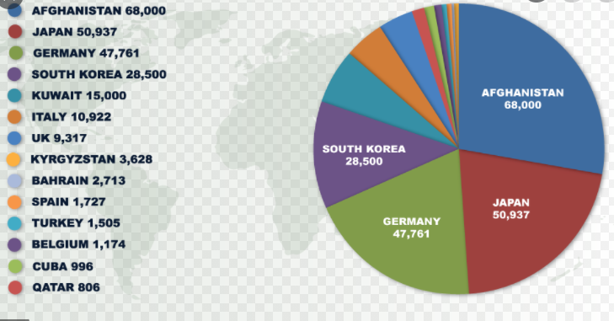
Figure 1:US Troop Deployments Overseas | Current and Historic Information
The caregivers and children affiliated with the military families experience child emotional challenges with increased intensity than it has ever been seen with the general U.S population (Nathan, 2018). The cumulative number of months associated with the parental deployment is closely related to the extent of the emotional challenge revealed by the children. The deployment duration is more likely the child is to meet social upbringing hitches (Nathan, 2018). From the study, the female gender and children during their adolescence (regardless of the sex) reveal more problems with parental reintegration and deployment. Children between the ages 10-14 are at high risk for psychosocial morbidity, which is connected to the parenting stress originating from the deployment activities.
The influence of deployment, as revealed from numerous studies, is a challenging affair in children. However, Lester et al. (2013) categorized the intensity of the deployment effects depending on the structure of a family. He noted that a family with a single child resulted in that child experiencing a more intense stress level than a child with siblings. The reason behind this argument is that when the single-based child experiences physical attraction to the parental on military duty, the child tends to stay quiet with the concern. Many of these kinds of children have an ill relationship with extended family members due to the higher chances of disregarding these children's needs in the absence of their parents. The child opts to stay silent while overthinking the current situation. The extra thoughts result in increased stress levels. On the other hand, children with siblings around tend to be somewhat occupied and jovial despite the parents being away (Lester, 2013). They equally share the available responsibilities with a desire to remain fondly connected with constant communication. In any case, one of the siblings feels off the mood, and the other tends to grow sympathetic to the other, returning the former to the initial good moods. The "keeping an eye" behavior among the siblings avoids any possible extreme effect of a stressful situation. Therefore, families with multiple children are better placed to commit to their deployment plan without many psychological effects to the children compared to a single child's situation.
Further, through the use of meta-analysis resources, it was evident that military spouses experienced an unlimited number of differences, leading to the depression state of many of them. A survey was conducted among 900 service members’ who were spouses. Among them, 10% were diagnosed with excessive depressive disorder. The survey indicated that the rest of the spouses were still prone to posttraumatic stress disorder. Although the survey suggested that the combat-related activities were not the only factors relating to stress evidence, it remains that they are the major causes (Mutillo, 2016). An extension in this study revealed that while most of these individuals were in military duty, they kept depressed with overthinking how their children were faring back at home. Particularly, the depression rate was pronounced to the spouses who had a single child (Mutillo, 2016).

Theoretical framework
Relying mainly on quantitative data presented from the secondary sources of printed forms, it was evident that the deployment plan of military-based parents was the most significant cause of psychological disorders among the children (Mutillo, 2016). The graph below summarizes this argument.

The research indicated that the deployment was the main source of stress for children (75%), followed by 58% that originated from other professions that had limited time of separation from their children compared to that in the military. Finally, 46% acted as the source of stress from internal factors such as personal motivation.
The study further indicated that 80% of single-existing children had more psychological disorders compared to only 40% of the children who coexisted with siblings. The children were categorically selected from the families of military spouses. The reason being that the single child tends to have low levels of immunity to the pressure resulting from the extended families, among other sources. The siblings had the tendency of "keeping an eye" on each other, hence minimal stress (Lester 2013). This explanation is summarised by the pie chart below.
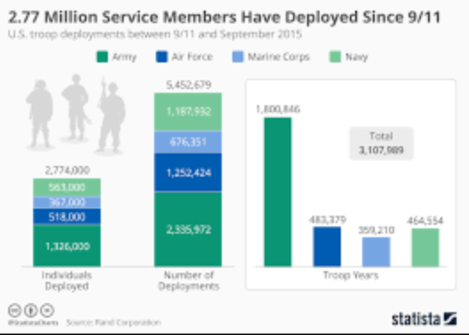

Conclusion
This research shows that military occupation causes pressure on the participant and the other members connected to that individual. The deployment activities act as the main source of stress due to the physical separation of the members. The children from military-based families revealed higher anxiety, less learning abilities, and experienced disrupted patterns of their sleep compared to the other children from families whose parents were from less demanding professions. Further, children who existed as a single without siblings revealed more significant stress levels than those who coexisted with their siblings.

The Research Gap
The strong reliance on secondary data as the only source of information is limiting. This is because different print materials offer to contradict opinions, and it requires a strong analysis to come up with informed research. More so, most of the materials do not major in informing specific challenges experienced by children on the virtue of existing as the only child or with siblings in a military-based family.

Recommendations
For future work, the inclusion of primary data into the thesis will be better. This will offer a comparison between what is available in the secondary data as well as that in primary sources. Further, this proposal focused on the extent of psychological torture between the children who exist with siblings and those who are the only ones in the family. I recommend for future research to pick one direction. For instance, research on the particular and unlimited details that cause more stress on an only child family than picking both classifications of the children.

References
Chartrand, Molinda & Frank, Deborah & White, Laura & Shope, Timothy. (2008). Effect of Parents' Wartime Deployment on the Behavior of Young Children in Military Families. Archives of paediatrics & adolescent medicine. 162. 1009-14.10.1001/archpedi.162.11.1009.
Clark, M. A., O'Neal, C. W., Conley, K. M., & Mancini, J. A. (2018). Resilient family processes, personal reintegration, and subjective well-being outcomes for military personnel and their family members. American Journal of Orthopsychiatry, 88(1), 99. https://www.google.com/search?q=Clark%
Cousins, S. B. (2017). Practitioners’ constructions of love in early childhood education and care. International Journal of Early Years Education, 25(1), 16-29. https://www.google.com/search?q=Cousins%
Cramm, H., McColl, M. A., Aiken, A. B., & Williams, A. (2019). The Mental Health of Military-Connected Children: A Scoping Review. Journal of Child & Family Studies, 28(7), 1725–1735. https://doi.org/10.1007/s10826-019-01402-y
Cunitz, K., Dölitzsch, C., Kösters, M. et al. Parental military deployment as a risk factor for children’s mental health: a meta-analytical review. Child Adolescent Psychiatry Mental. https://www.google.com/search?q=Cunitz
Castro, C. A. (2008). Prevalence of Mental Health Problems, Treatment Need, and Barriers to Care among Primary Care-Seeking Spouses of Military Service Members Involved in Iraq and Afghanistan Deployments. Military Medicine, 173(11), 1051–1056.https://doi.org/10.7205/MILMED.173.11.1051
James, T., & Countryman, J. (2012). Psychiatric effects of military deployment on children and families: the use of play therapy for assessment and treatment. Innovations in clinical neuroscience, 9(2), 16–20. https://www.google.com/search?q=James%
Lester, P., Stein, J. A., Saltzman, W., Woodward, K., MacDermid, S. W., Milburn, N., Mogil, C., & Beardslee, W. (2013). Psychological health of military children: a longitudinal evaluation of a family-centred prevention program to enhance family resilience. Military medicine, 178(8), 838–845. https://doi.org/10.7205/MILMED-D-12-00502
Mustillo S, Wadsworth SM, Lester P: Parental deployment and well-being in children: results from a new study of military families. J Emot Behav Disorders2016; 24(2): 82–91.
Nathan H Johnson, MC(E) USAR, Carol Vidal, MD, MPH, Flavius R W Lilly, Ph.D., MA, MPH, Absence of a Link Between Childhood Parental Military Service on Depression and Anxiety Disorders Among College Students, Military Medicine, Volume 183, Issue 910, September-October 2018, Pages e502–e508, https://doi.org/10.1093/milmed/usy003.
Shomali, W., & Gotlib, J. (2019). World Health Organization‐defined eosinophilic disorders: 2019 update on diagnosis, risk stratification, and management. American journal of hematology, 94(10), 1149-1167. https://www.google.com/search?q=Shomali%
Son, S. A. (2016). Identity, security and the nation: understanding the South Korean response to North Korean defectors. Asian Ethnicity, 17(2), 171-184. https://www.google.com/search?q=Son%

